**Project Design Phase-II**

**Data Flow Diagram & User Stories**

|  |  |
| --- | --- |
| Date | 06 May 2023 |
| Team ID | NM2023TMID20397 |
| Project Name | Estimation and prediction of hospitalization and medical care cost |

**Data Flow Diagrams:**

A Data Flow Diagram (DFD) is a traditional visual representation of the information flows within a system. A neat and clear DFD can depict the right amount of the system requirement graphically. It shows how data enters and leaves the system, what changes the information, and where data is stored.



Example: DFD Level 0 (Industry Standard)

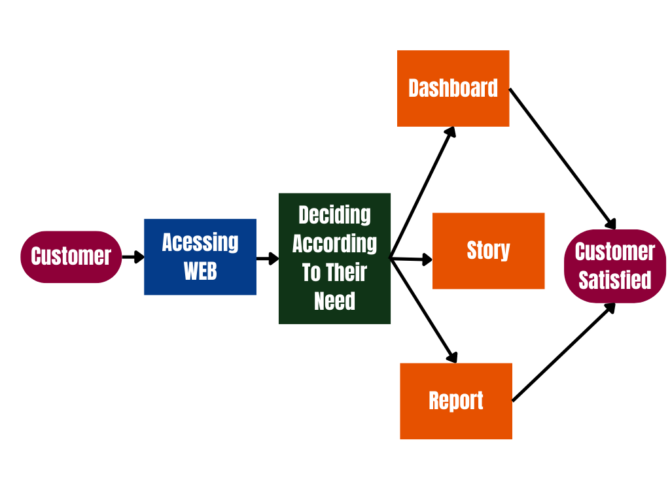**Example:** [**(Simplified)**](https://developer.ibm.com/patterns/visualize-unstructured-text/)

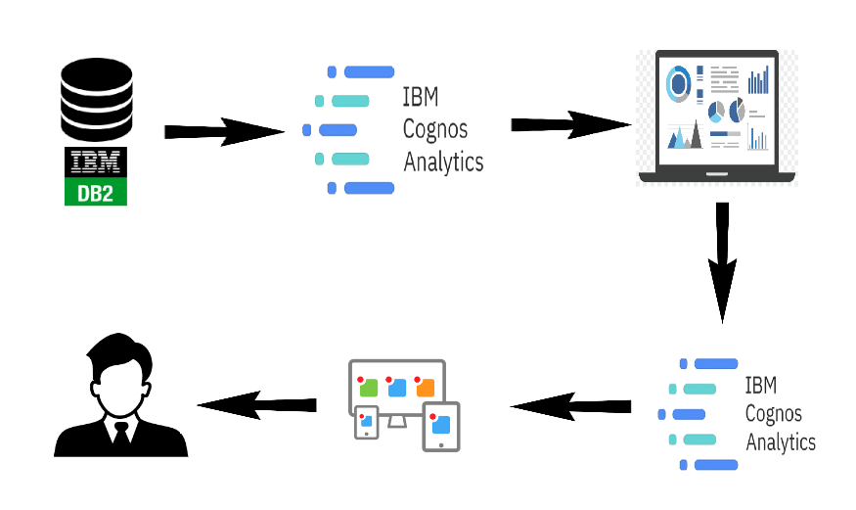

**User Stories**

Use the below template to list all the user stories for the product.

| **User Type** | **Functional Requirement (Epic)** | **User Story Number** | **User Story / Task** | **Acceptance criteria** | **Priority** |
| --- | --- | --- | --- | --- | --- |
| Customer (sports marketer) | Dashboard | USN-1 | As a user, I'm trying to identify the most promising Olympic sports and athletes to invest in. | I can access my dashboard | High |
| Customer (coach) | Dashboard | USN-2 | As a user, I'm trying to optimize my training programs to improve the performance of my athletes. | I can access my dashboard | High |
| Customer (sports journalist) | Report | USN-3 | As a user I'm trying to write engaging stories about Olympic sports and athletes. | I can access my Report,Story. | Low |
| Customer (Olympic athlete) | Dashboard | USN-4 | As a user, I'm trying to improve my performance in my sport. | I can access my dashboard | Medium |
| Customer (Fan) | Dashboard | USN-5 | As a user, I'm trying to gain a better understanding of the different sports and athletes competing in the games. | I can access my dashboard | Low |
| Customer (event organizer) | Report | USN-6 | As a user, I'm trying to create an engaging and successful Olympic sports event for spectators. | I can access my Report | Medium |
| Customer (sports data analyst) | Dashboard | USN-7 | As a user, I'm trying to develop accurate models for predicting the outcomes of Olympic sports events. | I can access my dashboard | Medium |
| Customer (sports sponsor) | Report | USN-8 | As a user, I'm trying to identify the most effective ways to promote my brand in connection with Olympic sports events. | I can access my report | High |
| Customer (Olympic sports broadcaster) | Dashboard | USN-9 | As a user, I'm trying to provide insightful and engaging commentary on live events. | I can access my dashboard | High |